**Unit 5 Do you want to watch a game show?**

**单元教学目标**

话题：娱乐活动（Entertainment）

功能：1.谈论对不同类型的电视节目或电影的看法与偏好（Talk about preferences）

2.制定计划（Make plans）

语法：不定式作宾语（infinitives used as object: *to do*）

A: What do you plan to watch tonight?

B: I plan to watch *Days of Our Past*.

What can you expect to learn from sitcoms?

Do you want to watch the news?

I hope to find out what’s going on around the world.

1. 能正确使用下列词汇：news, discussion, joke, action, cartoon, culture, reason, film, army, plan, hope, stand, happen, expect, appear, become, lose, may, might, educational, meaningless, famous, rich, successful, main, common, unlucky, ready, simple
2. 能正确使用下列常用表达：soap opera, find out, action movie, be ready to, dress up, take sb’s place, do a good job
3. 能够认读下列词汇：sitcom, comedy, girlfriend, character

**学习策略**

1. 在语言学习中把握文字传递的感情色彩，例如：love, like, don’t mind, don’t like, can’t stand等

2. 在阅读中把握信息呈现的时间线索

**文化知识**

了解卡通片在美国文化中的作用，以及美国著名卡通片和米老鼠等卡通形象

**Section A 1 (1a-2d)**

一、**教学目标：**

1.1) 学生能掌握以下单词：sitcom, news, stand, mind, educational, plan, hope, find out, discussion, happen, expect

能掌握以下句型：

① What do you want to watch?

② What do you think of talk shows?

③ I can’t stand them.

④ I don’t mind them.

⑤ I like/love them. / I don’t like them.

2) 能了解以下语法：

动词不定式结构作动词的宾语；后面接不定式作宾语的动词。

3) 教学生学会陈述自己的看法；学会谈论自己的喜好。

2. 教会学生谈论流行文化，了解各类电视和电视节目的名称和自己的爱好。注意引导学生们形成正确的文化观念，大力培养学生的跨文化意识，形成自己独立的个性。

二、**教学重难点**

1. 教学重点：

1) 学习掌握各类电视和电视节目的名称。

2) 掌握动词不定式作宾语；了解后面接不定式作宾语的动词。

2. 教学难点：

掌握动词不定式作宾语；了解后面接不定式作宾语的动词。

**三、教学过程**

**Ⅰ. Warming up**

Show some pictures of different kinds of TV programs, then practice the sentence:

What do you think of…?

**Ⅱ. Show the new words to Ss.**

sitcom *n*. 情景喜剧 news *n.* 新闻节目; 新闻

soap opera 肥皂剧

**Ⅲ.** Work on 1a

1. 引导学生看1a中的图片，根据提示依次说出每一幅图电视节目的名称。

2. 让学生们看图片及1a中的词汇，将图片与正确的词汇相连。

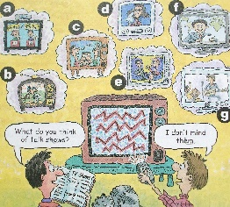

1. talk show ___ 2. soap opera ___ 3. sports show ___ 4. sitcom ___

5. game show ___ 6. talent show ___ 7. news ___

3. Check the answers with the Ss.

**Ⅳ. Listening**

1. Tell Ss to read the shows in the box. Make sure they know the meaning of the shows.

2. Play the recording for the Ss to listen and number the shows1—4.

1b Listen and number the shows [1—4] in the order you hear them.

__ talent show __ talk show __ soccer game __ news

3. Play the recording again.

Listen again and answer the questions.

1) What does Mark plan to do later?

2) What does Jack think of talk shows?

3) Does Jack like the news?

4) What does Jack think of talent shows?

5) Does Mark want to watch the soccer game at 5:00? How about Jack?

4. Play the once more. Check the answers with the Ss.

Answers: 1) He plans to watch TV.

2) He doesn’t mind them, but sometimes they can be a bit boring.

3) Yes, he does.

4) He usually can’t stand them, but the new one is quite funny.

5) Yes, he does. So does Jack.

**Ⅴ. Pair work 1c**

1. Let Ss read the conversation after. Then let Ss make their own conversations using the shows and expressions in the box.

A: What do you want to watch?

B: What do you think of talk shows?

A: They’re OK. I don’t mind them.

B: Then let’s watch a talk show.

2. Let some pairs ask and answer about the shows.

A: What do you want to watch?

B: What do you think of sports shows?

…

**Ⅵ. Listening**

Work on 2a:

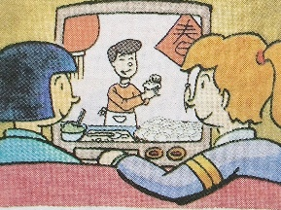

Pre-listening

1. Look at the picture and answer the questions.

1) Where are they?

2) What are they doing?

3) What are they probably talking about?

2. Read the shows in the box of 2a. Tell Ss to remember the information.

___ sitcoms ____ news ___ game shows ____ talk shows

___ soap operas

While-listening

1. Play the recording for the Ss to listen and number the TV shows [1-5].

___ sitcoms ____ news ___ game shows ____ talk shows

___ soap operas

2. Play the recording again to check the answers.

3. Work on 2b:

Listen again. Complete the sentences.

1) Sally likes to watch _______________________.

2) Lin Hui thinks she can learn _______________________ from sitcoms.

3) Sally thinks _______________________ are more educational than sitcoms.

4) Sally loves _______________________. She plans to watch *Days of Our Past* _______________________.

4. Play the recording for the Ss to write the correct words in the blanks.

5. Play the recording again to check the answers.

6. Listen once more then answer the questions.

1) What does Lin Hui think of sitcoms?

2) Does Sally like sitcoms? Why?

3) What kind of TV shows does Sally like?

4) What does Sally think of soap operas?

5) What does Sally plan to watch tonight?

Answers:

1) She thinks watching sitcoms is a great way to relax and she can learn some great jokes, too.

2) No, she doesn’t. Because she can’t learn from them.

3) Sally likes the news or talk shows.

4) She thinks it educational. She can try to guess the answers to the questions.

5) She can’t learn much from soap operas, but she loves watching them.

6) She plans to watch *Days of Our Past*.

**Ⅶ. Pair work**

1. Tell Ss ask and answer questions about the TV shows in 2a. They can use the information that is true for them.

2. Let Ss read conversation firstly.

A: Do you plan to watch the news tonight?

B: Yes. I like watching the news. I watch it every night.

A: Why?

B: Because I hope to find out what’s going on around the world.

3. Ss act the conversation in pairs. Ask some pairs to act out their conversations.

**Ⅷ. Role-play**

1. Read the conversations and match the persons with their favourite shows.

① Grace a. game shows and sports shows

② Sarah b. soap operas

③ Grace’s classmates c. news and talk shows

Keys: 1-b 2-c 3 -a

2. Read the conversation and answer the questions.

1) What are Grace and Sarah talking about?

2) What does Grace think of game shows and sports shows?

3) What does Grace think of soap operas? What does Sarah think of them?

4) What are Sarah’s favorite TV shows? What does Grace think of them?

Answers: 1) They are talking about TV shows.

2) She can’t stand them.

3) Grace loves soap operas. Sarah doesn’t mind soap operas.

4) Sarah’s favorite TV shows are the news and talk shows. Grace thinks they are boring.

3. Explain some new words and main points in the conversation.

4. Fill in the blanks according to the conversation.

Sarah had a discussion about TV shows in class. Her classmates _____________ game shows and _____________, but Grace can’t _____________ them. She _____________ soap operas. She likes _____________ (follow) the story and see what _____________ next. Sarah doesn’t _____________ soap operas, and her _____________TV shows are the news and talk shows. They may not be very exciting, but you can _____________ to learn a lot from them.

Keys: like, sports shows, stand, loves, to follow, happens, mind, favorite, expect

5. Read the conversation after the teacher.

6. Practice the conversation with the partners. Then let some pairs to act out the conversation.

**IX. Language points**

1. I don’t mind them.

我不介意它们。

*v.* 介意；当心；注意。后接名词(短语)、代词、动词-ing形式等。

e.g. Do / Would you mind going with me? 你介意和我一起去吗？

I don’t mind opening the door. 我不介意打开门。

*n.* 头脑；心智；思想；想法。

change one’s mind 改变主意

make up one’s mind 下定决心

【语境应用】完成句子。

1) 如果你改变主意了，给我打电话。

If you _______ _______ _______, just give me a call.

2) 你介意等一两天吗？

________ _______ _______ _______ a day or two?

3) Tom不介意每天晚上工作到很晚。

Tom _______ _______ _______ late every night.

2.Sally thinks game shows are more educational than sitcoms.

Sally认为竞技节目比情景喜剧更有教育意义。

educational *adj*. 教育的；有教育意义的

e.g. I think this movie is the most educational.

我认为这部电影最有教育意义。

拓展：

education (教育) + al → educational

多音节形容词, 其比较级及最高级形式在其前加more, most构成。

e.g. This story is more interesting than that one.

这个故事比那个故事能有趣。

3. She plans to watch *Days of Our Past* tonight.

plan *vt.* 打算；计划，其后可接名词或动词不定式等。

e.g. Can you help me plan my trip to Chengdu?

你能帮我制订去成都旅游的计划吗？

plan to do sth. 表示“计划或打算做某事”。

e.g. When do you plan to visit your grandparents?

你计划什么时候去拜访你的祖父母？

plan *n.* 计划；安排

e.g. My father is making a plan for teaching.

我父亲正在制定教学计划。

plan表示“有关……的计划”时，其后可接介词for引起的短语。

e.g. Do you have any plans for this weekend?

这个周末你有什么安排吗？

4. Because I hope to find out what’s going on around the world.

hope *n.* 希望

e.g. Don’t lose your hope! 不要灰心！

hope *v.* 希望

hope to do sth. 希望做某事 (能实现的理想)

hope for sth. 希望发生某种情况或得到某物

hope + that从句，希望某人做某事

e.g. They hope to take plane to Beijing next year.

他们希望明年乘飞机去北京。

I hope (that) you’ll have a good time at the party.

我希望你们能有一个愉快的聚会。

**【语境应用】完成句子**

1) 他们希望明天有好天气，这样他们就能去野营。

They ____________________ tomorrow, then they can go camping.

2) 我不认为我今天下午会忙，至少我不希望如此。

I don’t think I will be busy this afternoon; at least ____________________.

3) Mary希望你们能来。

Mary ____________________ can come.

4) 我们希望再次见到你。

We ____________________ you again.

Keys: 1) hope for good weather / hope the weather is good

2) I hope not  3) hopes (that) you  4) hope to see

find out 查明; 弄清 (指通过调查、研究等方式查明事情的真相)

find 找到；发现，强调动作的结果。

e.g. Did they find out where the old man lived?

他们查明那位老人住在哪里了吗？

Mr. Li found his lost keys in the library.

李老师在图书馆里找到了他丢失的钥匙。

5. We had a discussion about TV shows.

discussion *n*. 讨论; 商量

动词 discuss (讨论) + -ion→ discussion

e.g. Let’s discuss who is the best performer.

让我们讨论一下谁是最好的表演者。

Did you have a discussion about the food and drinks?

你们讨论过食物和饮料的事了吗？

6. Oh, I can’t stand them.

哦，我不能忍受它们。

stand *vt.* 忍受

e.g. How can you stand him?

你怎么能忍受得了他？

My father can’t stand action movies.

我爸爸受不了动作电影。

stand *vi.* 站(立)；位于

e.g. It looks like we’ll have to stand — there are no seats left.

看来我们只能站着了—没有座位了。

A tall tree once stood here.

这里曾经有一棵大树。

stand常用短语有stand up (起立)；stand for (代表；象征)等。

e.g. The students all stood up when the teacher got into the classroom.

当老师进教室时，学生们都站了起来。

Do you know what the three letters stand for?

你知道这三个字母代表了什么吗？

7. I like to follow the story and see what happens next.

我喜欢追剧情，看看下一集会发生什么。

happen *vi*. 发生; 出现

常用表达: sth. happens / happened to sb. 某人发生某事（主语为某事）

happen to do sth. 碰巧做某事

e.g. I happened to sit behind him.

我碰巧坐在了他后面。

I hope nothing bad happened to him.

我希望他没出什么事。

**【语境应用】完成句子**

1) 今天在我身上发生了一件有趣的事。

A funny thing _______ _______ _______ today.

2) 我给她打电话时，她碰巧出去了。

She _______ _______ _______ _______ when I called her.

8. Well, they may not be very exciting, but you can expect to learn a lot from them.

may *model v.* 也许; 可以; 可能

“may + 动词原形”一起构成句子的谓语。

e.g. You may go by bike or take the subway.

你们可以骑自行车去或乘地铁去。

expect sb. / sth.表示“期待某人 / 某事”。

e.g. I shall expect your opinion of it quite soon.

我希望你能尽快给我意见。

I’ll expect you for dinner at six o’clock.

我希望你六点吃晚餐。

expect to do sth.表示“期待 / 预料做某事”。

e.g. We are expecting to visit the Great Wall.

我们期待参观长城。

expect sb. to do sth.表示“期待 / 预料某人做某事”。

e.g. Do you expect me to stay here?

你希望我留在这里吗？

expect + that从句，表示“期待 / 预料……”。

e.g. I expect (that) you’ll be ready for the English exam.

我希望你会准备好这次的英语考试。

辨析 expect 和hope

|  |  |
| --- | --- |
| expect | 常侧重于相信或认为有可能实现的愿望，是出于有把握和根据的期望；  常接名词、动词不定式(短语)、动词不定式的复合结构(即“宾语+不定式”)  或that引导的从句 |
| hope | 常出于没有把握、没有根据的个人希望或愿望；常接动词不定式(短语)或that  引导的从句，不可接动词不定式的复合结构。 |

**X. Summary**

game show (电视)竞赛节目

talk show 脱口秀

learn…from… 从……学习……

soap opera  肥皂剧

soccer game 足球比赛

sports show体育节目

talent show 才艺表演

find out 查明；弄清

have a discussion about… 就……进行讨论

I don’t mind them. 我不介意它们。

I can’t stand them. 我无法忍受它们。

What do you think of talk shows?

I like to follow the story and see what happens next.

**XI. Exercises**

**Ⅰ. 根据句意及括号内所给单词的提示填空。**

1. A terrible fire __________ (happen) in the shopping center yesterday.

2. Is there any good __________(news) in today’s newspaper?

3. John likes different kinds of museums. He thinks they’re __________ (education) and interesting.

4. You can’t expect __________(learn) a new language in a short time.

5. Do you have any __________(plan) for the weekend?

**Ⅱ. 根据汉语意思，完成英语句子，每空一词。**

1. 他们花了一年的时间环游世界。

They spent a year travelling _______ _______ _______.

2. 请帮我弄清楚会议什么时候开始。

Please help me _______ _______ what time the meeting starts.

3. 我喜欢Helen，我认为我可以从她身上学到很多。

I like Helen and I think I can _______ _______ _______ _______ _______.

4. Mary通过她的舞蹈赢了才艺秀。

Mary won the _________ ________ by her dancing.

5. 我很害怕，但是生活必须继续下去。

I was afraid, but life must _________ _________.

6. 我们对两种语言的不同之处进行了讨论。

We _________ _________ _________ _________ the differences between two languages.

Keys:

Ⅰ. 1. happened 2. news 3. educational

4. to learn 5. plans

Ⅱ. 1. around the world  2. find out 3. learn a lot from her

4.  talent show                5. go on  6. had a discussion about

XII. Homework

Make a conversation by using the following expressions.

1. What do you think of …?

I like / I don’t like / don’t mind / can’t stand…

I think it’s / they’re…

2. plan to do… 3. hope to do…

4. find out … 5. can’t stand …

6. sth. happen 7. expect to do…

**Section A 2 (Grammar Focus-3c)**

一、**教学目标：**

1. 1) 学生掌握下列词汇：joke, comedy

2)让学生学会谈论计划、谈论对某种电视节目的看法、询问及说明原因、

深入谈论电视节目的交际用语。

3) 掌握动词不定式作宾语这一语法知识；掌握后面接不定式作宾语的动词。

2. 学会谈论流行文化，了解各类电视和电视节目的名称。 注意引导学生们形成正确的文化观念，大力培养学生们的跨文化意识，形成自己独立的个性。

二、**教学重难点**

1. 教学重点：

掌握动词不定式作宾语这一语法知识；掌握后面接不定式作宾语的动词。

2. 教学难点：

掌握动词不定式作宾语这一语法知识；掌握后面接不定式作宾语的动词。

**三、教学过程**

**Ⅰ. Revision**

1. Have a dictation of the new words learned in the last class.

2. Ask and answer questions about the different shows.

What do you think of news?

I can’t stand it. / I like it. / I don’t mind it. I…

3. Role-play the conversation in 2d.

**Ⅱ. Grammar focus**

1. 学生阅读Grammar Focus中的句子，然后做填空练习。

1) 你想看新闻吗？

Do you want to ______ ______ ______?

2) 是的，我想看。/ 不，我不想看。

Yes, I do. / No, I don’t.

3) 你计划今晚上看什么节目？

______ do you ______ ______ watch tonight?

4) 我计划看《我们过去的时代》。

I ______ ______ watch *Days of Our Past*.

5) 你期望从情景喜剧中学到什么？

What can you ______ ______ ______ from sitcoms?

6) 你能学到一些很好的笑话。

You can ______ some great ______.

7) 你为什么喜欢看新闻呢？

Why do you like ______ ______ ______?

8) 因为我希望了解在世界各地发生了什么事情。

Because I ______ ______ ______ ______ what’s going on around the world.

9) 你觉得访谈节目怎么样？

What do you think of ______ ______?

10) 我不介意看。/我不能忍受。/ 我喜欢看。

I don’t ______ them. / I ______ ______them. / I ______ ______ them!

2. 学生们根据记忆，看大屏幕来完成填空练习。

3. 学生们完成填空试题后，可以打开课本检查答案，对错误的句子，单独进行强化记忆。

4. 根据课本内容, 完成下列句子。

1. Do you _____________ the news?

2. What can you _____________ from sitcoms?

3. What do you ______________ tonight?

4. I _____________ *Days of Our Past*.

5. Because I ________________ what is going on outside.

上面例子中主要行为动词后面的动词都采用了“to + 动词原形”的结构，即动词不定式（有时可不带to）。

**Ⅲ. Grammar**

1. 总结交际用语：

谈论计划：

A: Do you want to watch the news?

B: Yes, I do. / No, I don’t.

A: What do you plan to watch tonight?

B: I plan to watch *Days of Our Past*.

谈论对某种电视节目的看法：

A: What do you think of talk shows?

B: I don’t mind them. / I can’t stand them. / I love watching them.

询问及说明原因：

A: Why do you like watching the news?

B: Because I hope to find out what’s going on around the world.

深入谈论电视节目：

A: What can you expect to learn from sitcoms?

B: You can learn some great jokes.

2. 不定式有两种形式：一种是带to的不定式，即to+动词原形；一种是不带to的不定式，即动词原形。

不定式(短语)在句中不能单独作谓语，但可以作主语、表语、宾语、定语、状语等。 在本单元我们主要学习带to的不定式(短语)作宾语的用法。带to的不定式(短语)在句中可作宾语。如：

David wants to study in the USA.

【温馨提示】

目前学过的可跟带to的不定式作宾语的动词有like, love, want, hope, wish, expect, decide, try, plan, forget, remember, start, ask, help, need, learn, seem。

注意： help可接带to的不定式或不带to的不定式作宾语，其意思不变。

带to的不定式和what, which, who, where, when, how等疑问词连用，在句中起名词的作用，也可以作宾语。如：

I know how to make cakes.

Bob doesn’t know where to go tomorrow.

【语境应用】根据汉语意思完成英语句子。

1) He _______ _______ _______(学习弹) the piano when he was a boy.

2) It _______ _______ _______(开始下雨) an hour ago.

3) You _______ _______ _______ _______(不需要走) now. It’s just 5:00.

4) John _______ _______ _______ _______(似乎很高兴) after hearing the good news.

**Keys:**  1) learned /learnt 2) started to rain 3) don’t need to go

4) seemed to be happy

根据所给词语的提示填空

1) We decided __________ (not go) out because of the bad weather.

2) I tried __________ (stop) her, but she was on her way to the teacher’s office.

3) —Do you remember __________(meet) her at my house last year?

—Yes. She was short and strong at that time.

4) Sue enjoys __________(listen) to music after reading.

5) His spoken English is very good but he has to practice __________(speak) it more.

**Keys:**  1) not to go 2) to stop 3) meeting 4) listening

5) speaking

**IV. Practice**

Work on 3a:

Make a conversation and then practice it with a partner.

A: What do you plan to watch on TV tonight?

B: I hope to _________________, but I also want to _________________. How about you? Do you _________________ a talk show or _________________?

A: Oh, I want to _________________.

1. Tell Ss to read the conversation in 3a and try to fill in the blanks with right words.

2. 方法指导：应通读整个对话，掌握对话大意；

然后，根据问句所问的内容及自己的实际情况来回答问题。

3. 学生们按照老师指导的方法进行阅读，并逐句推敲每空应填什么词语，在实际运用中提高自己的阅读能力、分析能力及综合运用能力。

4. 最后，教师与学生一起校对答案，并对学生们有疑问的地方进行解释。

5. 学生们两结对操练对话，最后找几名学生来表演对话。

Work on 3b:

Answer these questions. Give answers that are true for you.

1) What do you think of game shows?

_____________________________

2) What comedy shows do you like to watch?

_____________________________

3) Do you plan to watch a sports show tonight?

_____________________________

4) What can you expect to learn from the news?

________________________________

1. 让学生们阅读表格中的问题，明白每个问题的意思。

2. 让学生们思考一下他们自己的实际情况，并做出正确的回答。

3. 让学生们互相检查自己所写的句子，发现并改正错误。

4. 让部分学生就这些问题进行问答，说出自己所写的句子。大家一起改正句子中的错误。

Word on 3c:

Ask your classmates questions and write their names in the chart.

|  |  |
| --- | --- |
| Find someone who … | Students’ names |
| wants to watch a movie |  |
| hopes to watch a sitcom |  |
| expects to watch the news |  |
| plans to watch a sports show |  |
| never wants to watch a game show |  |

1. 让一名学生读表格中的内容。并告诉学生们本学习活动的要求。

2. 先由一名学生们对自己的小组成员进行提问，询问每一名成员希望看什么节目。然后，在表格中的适当位置记下他们的名字。

3. 由其余的同学根据表格中的情况来写一个小组成员情况的报告。大家互相讨论一下这些报告，最后，确定出一个最完整且没有错误的报告。

4. 由这名学生来向同学生汇报自己小级的情况。

(最后，可以经学生们评议来推举最有能力的小组）

**Ⅴ. Exercises**

**Ⅰ. 根据句意及括号内所给词的提示填空。**

1. I happen _________ (know) John’s phone number. It’s 396-2366.

2. They seem _________ (have) lots of money.

3. I will call you after I finish _________(do) my homework.

4. I’m still looking for a job and I wish _________(find) one soon.

5. It started ___________ (rain) in the middle of the night.

6. The fine weather helped ___________ (make) it a very enjoyable trip.

7. She tried ___________ (not laugh), but failed (失败).

8. Would you like ___________(come) for dinner tonight?

**Ⅱ. 根据短文内容及括号内所给单词的提示补全短文。**

Hi John,

How are things going there? We’re all fine. And we can’t wait (1)_______(see) you again on New Year’s Eve. Dad plans (2)_______(buy) some fireworks (烟火) and we all want (3)_______(have) a meal in Mom’s favorite restaurant.

Now we’re enjoying (4)_______(have) a few days off. We need (5)_______(relax) and do some shopping. We also hope (6)_______(visit) Aunt Anne next week before we go back to work. But it depends (取决于) if it will snow or not. It’s quite difficult (7)_______(get) to her house when there is snow. Usually she (8)_______(ask) us to wait until (直到) spring. She says she will come to visit us soon.

Oh, (9)_______(let) me know when you arrive and I will have Dad meet you at the train station. He will try (10)_______(get) there earlier.

Have a good day and see you on the 31st!

Steve

**Keys:**

Ⅰ. 1) to know 2) to have 3) doing 4) to find 5) raining / to rain

6) (to) make 7) not to laugh 8) to watch

Ⅱ. 1) to see 2) to buy 3) to have 4) having 5) to relax

6) to visit 7) to get 8) asks 9) let 10) to get

**VI. Homework**

What do your family members want to watch?

My mother likes sitcoms. She thinks they’re interesting. …

Finish your report.

My father doesn’t like soap operas. He loves watching news. He expects to …

My brother likes …, because …

My sister likes …

My grandma doesn’t like …

My grandpa loves …

**Section B 1 1a-1d**

一、**教学目标：**

1. 学生能够掌握以下单词和句型

单词：meaningless, action, action movie, cartoon

句型：① I like to watch action movies because they’re exciting.

② John wants to watch talk shows because they’re enjoyable.

2. 了解他人对不同的电影或电视剧的看法，明白不同的人有不同的喜好，从而明

确人们喜好的差异性。

二、**教学重难点**

1. 教学重点：

1) 掌握本课时出现的生词及表达方式。

2) 进行听力训练，提高综合听说能力。

2. 教学难点

听力训练

**三、教学过程**

**Ⅰ. Revision**

看图, 根据所给的单词和短语完成句子。(动词不定式)

**Ⅱ. Warming up**

T: Show some movies or shows on the big screen.

What do you think of game shows? Why?

Let Ss discuss about them. Ask and answer what they think of them.

**III. Brainstorming**

What kind of movie do you like? What do you think of it?

**New words**

cartoon *n*. 动画片; 卡通片

comedy *n*. 喜剧片

action movie 动作电影

scary movie 恐怖电影

Present new words about movies to Ss.

**Ⅳ. Work on 1a**

What do you think of these TV shows and movies? Choose words from the box and write them under the pictures (Page 36). Each picture can have more than one word.

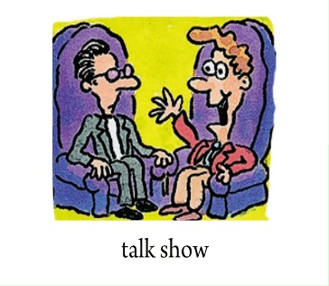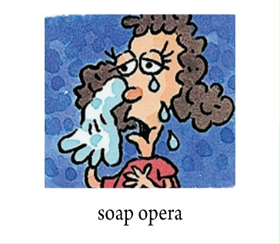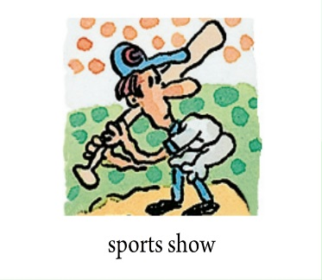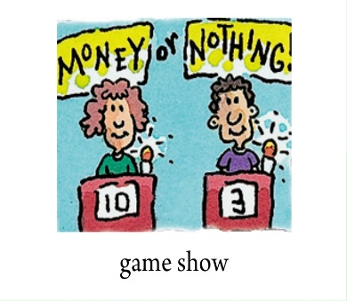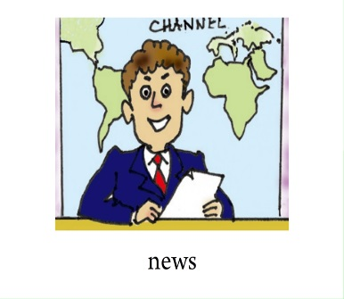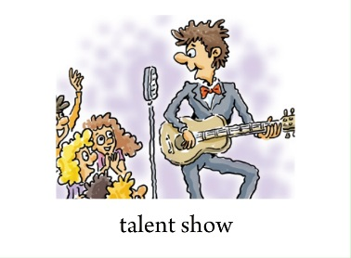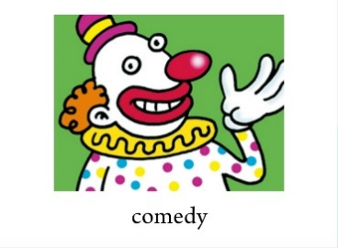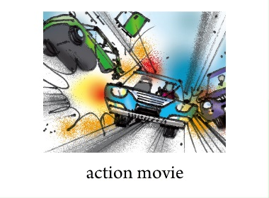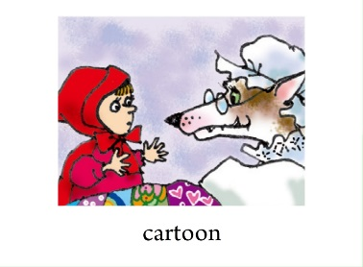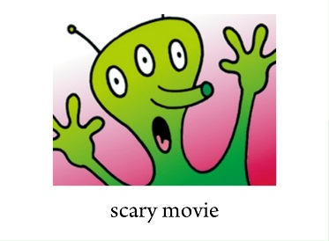

|  |
| --- |
| educational serious wonderful relaxing  meaningless enjoyable exciting boring |

1. Work with your partners. Ask and answer about the movies or shows.

2. Let Ss work in group to talk about the TV shows and movies.

**Ⅴ. Listening**

Work on 1b:

1. Listen and circle the description words you hear in the box in 1a.

|  |
| --- |
| educational serious wonderful relaxing  meaningless enjoyable exciting boring |

Tell Ss to listen and circle the description words you hear in the box in 1a.

2. Play the recording for the Ss. Ss just listen for the first time. Play the recording again and circle the words.

3. Play the recording and check the answers with the Ss.

Work on 1c:

Listen again. Write down the words John and Mary use to describe the TV shows or movies.

|  |  |  |  |  |  |
| --- | --- | --- | --- | --- | --- |
|  | **Action movies** | **Scary movies** | **Game shows** | **Sitcoms** | **Talk shows** |
| **John** | **exciting** |  |  |  |  |
| **Mary** |  |  |  |  |  |

1. T: Now please look at the chart in 1c. What do John and Mary think of the movies or shows? You'll listen to the tape again. Then try to fill in the blanks.

2. Ss listen to the recording carefully and try to fill in the blanks.

3. Play the recording again and check the answers with the class.

4. Answer the questions.

1) What did Mary want to watch at the beginning?

2) What kind of movies does John like? Why? What does Mary think of them?

3) What kind of TV shows does Mary like? Does John like them? Why?

4) What kind of TV shows do John and Mary both like? What do Mary and John think of them?

**Ⅵ. Talking**

1d Tell your partner what John and Mary like to watch and why. Then tell your partner what you like to watch and why.

*John wants to watch talk shows because they’re enjoyable. I like to watch action movies because they’re exciting.*

**Ⅶ. Summary**

action movie  动作影片

scary movie  恐怖电影

How about something exciting…

I think those movies are so meaningless.

I want to watch something relaxing…

I think they’re boring.

I think they’re wonderful.

**VIII. Exercises**

1. Judy doesn't like seeing _______ _______(动作影片).

2. Jane never sees scary movies. She thinks they are ________________. (meaning).

3. Linda saw two _______________(电影) last night and both of them were interesting.

**X. Homework**

* Write a passage to tell what your family like to watch and why.
* Preview the passage in 2b.

**Section B 2 2a-2e**

一、**教学目标：**

1. 学生能够掌握以下单词和句型

1) 单词：culture, famous, appear, become, rich, successful, might, main, reason,

common, film, unlucky, lose, girlfriend, ready, be ready to, character, simple

2) 句型：

① One of the main reasons is that Mickey was like a common man.

② However, he was always ready to try his best.

③ People went to the cinema to see the “little man” win.

2. 学生能够完成篇章的阅读任务，并通过对文章的学习了解米老鼠的诞生和成名过程以及人们喜欢它的原因。从而了解世界其他国家的文化，形成跨文化的意识。

二、**教学重难点**

1. 教学重点：

1) 掌握本课时出现的生词及表达方式。

2) 阅读短文，获得相关信息，提高学生们的综合阅读能力。

2. 教学难点

1. 听力训练

2. 阅读2b部分的短文并完成相关要求。

**三、教学过程**

**Ⅰ. Revision**

Tell your partner what you like to watch and why.

A: What kind of movies or TV shows do you like?

B: I like to watch … because they’re ... Do you like …?

A: I think they’re ... And I want to watch … because they’re …

**Ⅱ. Warming up**

T: Show some pictures about cartoons on the big screen.

Let Ss discuss about them. Ask and answer what they think of them.

*Do you like to watch cartoons?*

*What’s your favorite cartoon?*

*Why do you like it?*

*Do you like Mickey Mouse?*

**Ⅲ. Pre-reading**

How much do you know about Mickey Mouse?

Mickey Mouse is a funny animal cartoon character and the mascot (吉祥物) of The Walt Disney Company. He was created by Walt Disney in 1928.

Walt Disney (December 5, 1901 – December 15, 1966) was an American entrepreneur(企业家), animator (动画片绘制者), voice actor and film producer.

Ask Ss to look at the photo and guess what the passage may talk about.

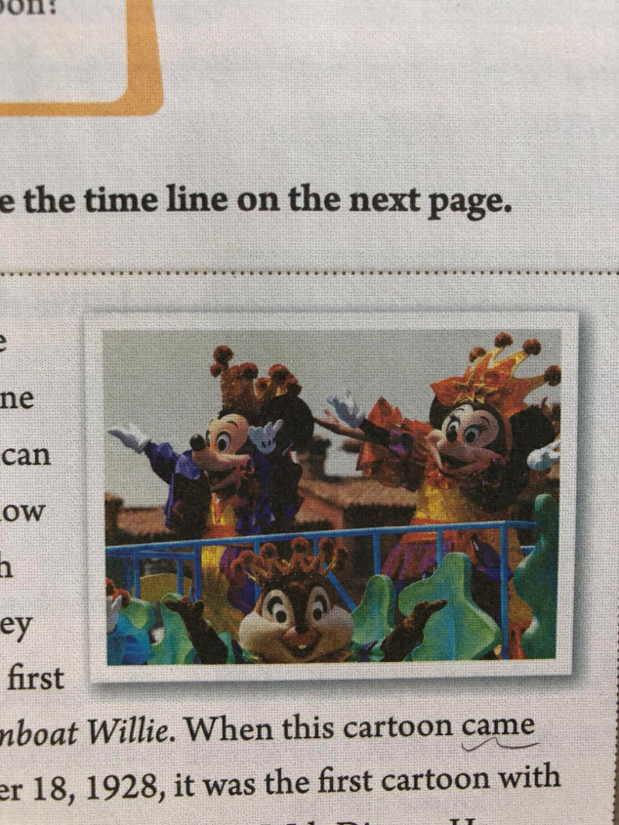

**Ⅳ. Reading**

Fast reading

1. Listen and read the passage, then find the main idea.

1) Mickey Mouse, a famous symbol in American culture

2) Some Cartoons with Mickey Mouse

3) Disney theme parks around the world

4) What people think of cartoons

2. Work on 2b.

Read the passage and complete the time line.

Let Ss read the passage quickly and complete the time line on next page.

Careful reading

3. Read the passage and mark T or F.

(  ) 1. Mickey Mouse is a symbol of American culture.

(  ) 2. *Steamboat Willie* is the first cartoon with sound and music.

(  )3. In his early films, Mickey was lucky.

(  ) 4. Mickey became very hot on the Hollywood Walk of Fame in 1988.

4. Read the passage carefully and complete the blanks.

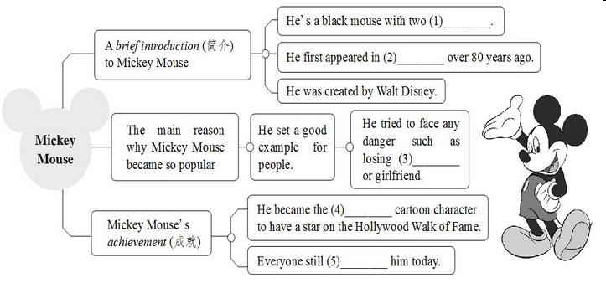

5. Work on 2c.

Read the passage again and fill in the facts about Mickey.

|  |  |  |  |  |  |
| --- | --- | --- | --- | --- | --- |
|  | What does he look like? | Who created him? | What was his first cartoon? | Who is his girlfriend? | Why is he popular? |
| Mickey Mouse |  |  |  |  |  |

6. Work on 2d

Read the passage again and discuss the questions with a partner.

1) What is Mickey Mouse a symbol of? What cartoon character is a symbol of Chinese culture?

2) Do you think Walt Disney is a smart man? Why or why not? Do you want to be like him?

3) Why did people want to be like Mickey? Do you want to be like Mickey? Why or why not?

4) Can you think of another cartoon character that is as famous as Mickey? Why is the character popular?

T: Read the passage again. This time you should discuss the questions with a partner.

Let some Ss talk about their answers.

**Ⅴ. Language points**

1. When people say “culture”, we think of art and history.

culture *n*. 文化; 文明

常用作不可数名词，但当表示某一特定形式的文化或某种类型的文化时，为可数名词。

e.g. China has a long history and culture. 中国有着悠久的历史和文化。

Just like me, my host parents love to learn about different cultures.

正像我一样，我的寄宿家庭的父母喜欢了解不同的文化。

2. But one very famous symbol in American culture is a cartoon.

famous *adj*. 著名的; 出名的

e.g. She is a famous actress.

This is a famous photo of the earth from space.

辨析 **be famous for, be famous as, be famous to**

|  |  |
| --- | --- |
| 词组 | 含义及用法 |
| be famous for | 因为……而出名，后接出名的原因。  当主语是人时，常表示某人以某一技能或特点而出名；当主语是地点名词时，常表示某地以某一名胜古迹或特产而出名。 |
| be famous as | 作为……而闻名，后接表示职位、名称等的词。 |
| be famous to | 为……所熟知+人 =be well-known to |

e.g. Beijing is famous for the Great Wall.

The town is famous for its apples.

Tu Youyou is famous as a great scientist.

My home town is famous as a green tea producing place.

Monkey King is famous to the children around China.

【语境应用】用适当的介词完成句子。

1) The town is famous _____ its hot springs.

2) Mr. Brown is famous _____ both a teacher and researcher.

3) Mother Teresa is famous _____ her work with the poor.

4) The movie *Ne Zha* is quite famous ______ many children in China.

My hometown, Kunming, is famous _______ fresh flowers. No matter when you visit it, they will catch your eye. (2020昆明)

A. as B. for C. of D. by

3. Over 80 years ago, he first appeared in the cartoon *Steamboat Willie*.

appear *v*. 出现

反义词：disappear 消失 disappearance *n*. 出现

类似以dis-为否定前缀的词还有disagree(不同意)和dislike(不喜欢)等。

e.g. A bus appeared around the corner.

一辆公共汽车出现在拐角处。

Does the sun appear on the horizon(地平线) at six?

太阳在六点露出地平线吗？

【语境应用】请将下列汉语句子翻译为英语。

1) 当那个演员出现的时候, 我们都站起来鼓掌。

2) 好像我的钱包不见了。

4. When this cartoon came out in New York on November 18, 1928, it was the first cartoon with sound and music.

当这部卡通片于1928年11月18日在纽约上映时，它成了第一部带有配音和音乐的卡通片。

come out 发行，出版；（太阳、月亮或星星）出现，露出；开花，盛开；被获知，为人所知

e.g. My first book came out in 2003. 我的第一本书于2003年出版。

The sun is coming out. 太阳要出来了。

Some flowers begin to come out. 有些花开始盛开了。

The truth has come out at last. 事情终于真相大白了。

【语境应用】回译句子。

当这部卡通片于1928年11月18日在纽约上映时，它成了第一部带有配音和音乐的卡通片。

5. He became very rich and successful.

become *v.* 开始变得; 变成 过去式：became

e.g. It became really hot in the afternoon. 下午天气变得很炎热。

rich *adj.* 富有的 反义词：poor 贫穷的 be rich in 富含……

e.g. At first, only very rich people had gardens. 起初，只有很富有的人才有花园。

The picture is rich in information. 这幅图片信息丰富。

successful *adj.* 获得成功的；有成就的

名词 success + -ful → successful在句中可作表语、定语。

在英语中一些名词加后缀-ful可变为形容词，如：beautiful(美丽的)，careful(仔细的)，helpful(有帮助的)等。

e.g. He is a successful basketball player. 他是一名成功的篮球运动员。

【语境应用】根据句意用success的适当形式填空。

1) We all think the movie is a __________.

2) Mary thinks that the man is a __________ actor.

You need not only talent but also hard work to become a ________ football player. (2019 江苏盐城)

A. young B. successful C. happy D. friendly

6. Some people might ask how this cartoon animal became so popular.

might *model v.* 可能; 可以 (用来表示推测，语气比may更加委婉和客气。)

e.g. He might get there in time, but I am not sure.

It might rain tomorrow.

1) You are not allowed to play with fire in the forest. It _______ kill plants, animals and even people. (2020云南昆明)

A. might B. might not C. should D. should not

2) – Where’s Jane?

-- I’m not sure. She ______ in the library. (2020湖南怀化)

A. might be B. must be C. can’t be

6. In the 1930s, he made 87 cartoons with Mickey.

在20世纪30年代，他制作了87部米老鼠卡通片。

in the 1930s 在20世纪30年代

在……世纪……年代：in+the+整十年份-s/-’s。

e.g. in the 1970s/1970’s 在20世纪70年代

7. Some people might ask how this cartoon animal became so popular.

有些人可能会问这个卡通动物是如何变得这么受欢迎的。

might *model v.* 可能; 可以

(用来表示推测，语气比may更加委婉和客气。)

e.g. He might get there in time, but I am not sure.

他可能及时赶到那里，不过我不确定。

It might rain tomorrow.  明天可能要下雨。

【语境应用】完成句子。

1) You are not allowed to play with fire in the forest. It ______ kill plants, animals and even people. (2020云南昆明)

A. might B. might not C. should D. should not

2) — Where’s Jane?

— I’m not sure. She ______ in the library. (2020湖南怀化)

A. might be B. must be C. can’t be

8. One of the main reasons is that Mickey was like a common man, but he always tried to face any danger.

主要的原因之一是米老鼠像一个普通人，但他总是全力以赴地去面对任何危险。

main *adj.* 主要的; 最重要的。无比较等级，常在名词前作定语。

e.g. Who’s the main character in the film? 这部电影的主角是谁？

reason  *n.* 原因，理由

the reason for (doing) sth. （做）某事的理由

the reason why… ……的原因

e.g. Why didn’t you give any reasons? 你为什么没给出任何理由？

You have no reason for doing that. 你没有理由做那件事。

We don’t know the reason why he was late. 我们不知道他迟到的原因。

face  *n.* 脸，面孔；表情

face to face 面对面

make faces 做鬼脸

*v.* 面对；面向 后可接名词或代词

e.g. Everyone must face the fact. 每个人都必须面对现实。

Lucy turned and faced me. Lucy转过身来面对着我。

I could see from the look on her face that something was wrong.

从她脸上的表情我可以看出事情不对劲。

9. Mickey was unlucky and had many problems such as losing his house or girlfriend, Minnie.

unlucky *adj.* 不幸的; 不吉利的

前缀(un) + lucky (幸运的) → unlucky 例如：unhappy 不高兴的

e.g. She’s unlucky — she never wins a game.

她运气不好——从未赢过一场比赛。

lose *v*. 失去；丢失

过去式和过去分词均为lost。lose后面既可以跟失去的事物，也可以跟输掉的比赛等。

e.g. I lost my keys. 我的钥匙丢了。

I hope we won’t lose the basketball match tomorrow.

我希望我们明天篮球比赛不要输。

10. However, he was always ready to try his best.

然而, 他总是准备好去尽其所能。

be ready to do sth., 准备好(做某事); 愿意(做某事)

ready *adj*. 愿意的；准备好的

be ready for sth. 为……做好准备（表状态）

get ready for sth. 为……做好准备（表动作）

e.g. We are ready for the exam. 我们准备好考试了。

【语境应用】完成句子。

My English teacher is always r_______ (准备好) with advice for our study and life.

try one’s best 尽力; 竭尽全力 =do one’s best

try/do one’s best to do sth. 某人尽力做某事

e.g. Tom is trying/doing his best to win the competition. Tom

正竭尽全力赢得比赛。

11. On November 18, 1978, Mickey became the first cartoon character to have a star on the Hollywood Walk of Fame.

to have a star ...是动词不定式短语作后置定语，修饰the first cartoon character。

... the first +名词 / 代词+动词不定式：……是第一个做某事的人或物”。当名词或代词前有序数词、形容词最高级或only等词时，常用动词不定式(短语)作后置定语。

【语境应用】完成句子。

1) John is always ____________________(第一个起床的人) in his family.

2) He was __________________________________(唯一一个完成工作的人) on time.

3) I don’t think it’s ____________________(最好的居住地方) in our country.

**Ⅵ. Making sentences**

Underline the following phrases in the passage. Write your own sentences or questions using the phrases.

think of ___________________________

come out __________________________

one of the main reasons _____________

such as ___________________________

was ready to ______________________

try his best _______________________

*What do you think of the book?*

*That magazine comes out once a month.*

*One of the main reasons is that I am hard-working.*

*He know four languages, such as Chinese and English.*

*Tom was always ready to help others when he was young.*

*He tries his best to do the work.*

**Ⅶ. Summary**

come out 出版

think of 想到；想起

cartoon with sound and music 带有配音和音乐的卡通片

in the 1930s  在20世纪30年代

one of the main reasons 主要原因之一

face any danger  面对任何危险

be always ready to do sth. 总是准备好做某事；总是乐意 / 愿意做某事

try one’s best 尽力

**Ⅷ. Exercises**

**Ⅰ. 根据句意及所给汉语提示，写出所缺单词。**

1. These two countries have different _______(文化). We should respect (尊重) them.

2. We missed him, but he never _______(出现) again.

3. In recent (最近) years, shopping online is _______(开始变得) more and more popular in our lives.

4. Usually face-to-face meetings are _______(获得成功的) than e-mails and phone calls.

5. Lisa didn’t come to my birthday party for some _______(理由).

**Ⅱ. 根据语境，从方框中选择恰当的单词填空，注意形式变化。每词限用一次。**

|  |
| --- |
| lucky, rich, common, famous, main, meaning, lose, film |

1. Many children are interested in cartoons. However, some parents think cartoons _______.

2. The _______ person is not the happiest person.

3. Mickey Mouse and Donald Duck are both _______ characters in the Disney cartoon.

4. His name was Wang Qiang, a(n) _______ name in China.

5. Sarah often watches _______ or her favorite shows on TV in rainy weather.

6. —Peter ran to the bus stop but still missed the last bus.

—How _______ he was!

7. A friend is easier _______ than found.

8. Many people like her songs. She is _______ as a singer than as a writer.

**Ⅲ. 根据汉语意思，完成英语句子，每空一词。**

1. For me, it’s _______ _______ _______(像……一样简单) ABC.

2. Who is your favorite _______ _______ _______(动作影片明星)?

3. It’s 5:30. We _______ _______ _______ _______ _______(准备好回家) now.

4. We didn’t recognize (认出) the criminal, because he _______ _______ _______ _______ _______ (装扮成了学生的样子).

5. Can you help me find someone to _______ _______ _______(代替Helen)?

6. They finished the job on time and _______ _______ _______ _______(干得好).

7. This newspaper _______ _______(出版) every Thursday.

8. I will enjoy my life and _______ _______ _______(尽力) to do everything well.

**Ⅸ. Homework**

1. Retell the passage.

2. Remember the words, phrases and sentences in the lesson.

**Section B 3 (3a-Self Check)**

一、**教学目标：**

1. 1)学生能够掌握以下词汇: dress up; take sb.’s place, army, do a good job

2) 复习to不定式作宾语的用法。掌握后面跟不定式作宾语的动词。

2. 学生能够综合运用所掌握的知识来描述自己所喜欢的一些动画片或影视剧。

3. 教会学生如何写影评。

4. 让学生了解一些影视片的内容，通过观看不同形式的影视片来了解社会，丰富自己的文化知识。

二、**教学重难点**

**1. 教学重点：**

1) 能运用所学的知识及提示来阅读相关影视片的简介，并能完成相关任务。

2）能运用所学的知识与句型表达方式来简介一下自己所看过的影视片。

2. 教学难点：

能运用所学的知识与句型表达方式来简介一下自己所看过的影视片。

**三、教学过程**

**Ⅰ. Revision**

Review the main phrases learned yesterday.

(1) 想起 __________

(2) 例如________

(3) 发行；出版 _________________

(4) 在二十世纪三十年代 ______________

(5) 主要原因之一___________________

(6) 努力做某事 ________________

(7) 愿意迅速做某事_______________

(8) 尽最大努力_____________

(9) 不仅仅；不只___________

Fill in the blanks to explain why Mickey is popular.

Some people might ask ____ this cartoon animal became so popular.

_____________________ is that Mickey was like a common man, but he always

_______face any danger. In his early films, Mickey was unlucky and had many

problems _______losing his house or girlfriend. However, he _______________

to __________. He is a ______ of American culture.

**Ⅱ. Warming up**

Ask some questions about *Mulan*. Let the Ss think and answer the questions:

“Do you like cartoons? Do you know *Mulan*? Can you say anything about it?”

Ss discuss the questions and answer the questions.

S1: Yes, I do. Mulan didn’t have any brothers. She took her father’s place to fight in the army.

S2: Mulan dressed up like a boy. Nobody knew she was a girl in the army.

**Ⅲ. New words**

1. dress up 装扮; 乔装打扮

e.g. The girls dressed up to take part in the party. 女孩子们打扮起来去参加舞会。

2. take one’s place 代替; 替换

e.g. A robot will take his place. 一名机器人将代替他的位置。

3. army *n*. 陆军; 陆军部队

e.g. My brother joined the army last year. 去年我哥参了军。

4. do a good job 干得好

e.g. I hope you’ll do a good job in the company. 希望你在公司好好干。

**Ⅳ. Reading**

Work on 3a. Fill in the blanks in the movie review. Use the words in the box to help you.

|  |
| --- |
| fantastic shows action want comes from played about like exciting plan |

*Mulan* is an ________ ______ movie. It ___________ an old Chinese story. The movie is ______ a village girl, Mulan. She dresses up like a boy and takes her father’s place to fight in the army. I think the actress _______ Mulan’s role well. The other actors are also _________ and they did a good job in the movie. I _____ Mulan very much. The movie _______ her love for her family, friends and country. If you ______ to watch a movie this weekend and you ______ to see something enjoyable, choose *Mulan*!

1. Read the article about *Mulan*. Fill in the blanks in the movie review. Use the words in the box to help you.

2. 阅读指导：

首先，阅读短文，整体把握短文大意。

其次，分析有空格的每个句子，看空格处的意思，联系所给单词的意思，确定空格处应填的单词。

最后，再通读一遍短文，看是否通顺合理。

3. Ss read the article and try to fill in the blanks.

4. Check the answers with the Ss.

**Ⅴ. Pre-writing**

Work on 3b:

1. Think about your favorite movies. Write notes for your own movie review.

2. Give some examples to the Ss.

The name of the movie:

The kind of movie: _________

What the movie is about? ____________________________________

What you think of the movie/star? _____________________________

3. Ss try to think about their favorite movies. Write notes for their own movie review.

4. Try to fill in the blanks.

**Ⅵ. Writing**

Work on 3c:

1. Write about your movie review using the notes in 3b.

2. 写作指导：

* 文体：议论文。
* 时态：写影评用一般现在时。
* 人称：介绍电影中的人物和故事梗概时用第三人称，表达自己观点时用第一人称。

3. 学生们根据写作提示，及上面表格中的提示来完成写作任务。

4. Useful Sentences

1) content:

The movie is about ...        The movie shows ...

The film tells the story of ...        It’s a love story ...

The story happened ...        The movie tells me that ...

2) comment (评论):

I think the actress played ... role well.

The actors did a good job in the movie.

I enjoyed the movie very much.

It was very long.

The acting was true to life / excellent / weak (欠缺的) ...

It has a tragic (悲惨的) ending.

The dialogues are touching / boring ...

One of the most interesting parts is ...

3) recommendation (推荐):

Don’t miss it.

All in all, it’s worth (值得) seeing.

The film is a must-see.

It’s a film with a deep message.

I think it’s a good movie with ...

5. Let some Ss read their passage to the class.

6. Sample writing

*Red cliff* is an exciting historical movie. The movie is about a famous battle that took place in southern China in 208 CE. The Prime Minister Cao Cao forces the Emperor Han to go to war with the kingdoms of Shu and East Wu. To protect themselves, the kingdoms of Shu and East Wu decide to form a partnership to fight against Cao Cao and his army. I enjoyed the movie very much. I think it is a great movie with a lot of good action scenes and strong characters. If you like history, you should watch *Red Cliff*!

**Ⅶ. Pair work**

1. Read the kinds of shows or movies in the chart in 4. Ask and answer about them with a partner. Write the answers in the chart.

2. Give Ss some examples:

S1: What do you think of soap operas?

S2: I think they’re boring. What about you?

S1: Well, I don’t like them, either.

3. Ss ask and answer with their partners and try to fill in the chart.

4. At last, write a short report about your ideas and your partner’s.

**Ⅷ. Summary**

do a good job  干得好

dress up 装扮；乔装打扮

take one’s place 代替；替换

fight in the army 从军打仗

**Ⅸ. Self check**

Work on Self check 1:

Write questions and answers using the words in brackets.

1) A: ______________________________ (what / think of / soap operas)

B: ___________________ (can’t stand)

2) A: ______________________________ (what show/ want to watch / tonight)

B: ____________________________ (talent show)

3) A: ______________________________ (what / expect to learn / game show)

B: ______________________________ (interesting information)

4) A: ______________________________ (what / hope to watch / tomorrow)

B: ____________________________ (news)

5) A: ______________________________ (do / plan to watch / action movie)

B: ____________________________ (no / plan to watch / comedy)

Work on Self check 2

Which of the statements do you agree with (√) or disagree with (×)? Give at least one reason.

1) I think game shows are meaningless. ( )

2) I can’t stand soap operas. ( )

3) I think sitcoms and talent shows are relaxing. ( )

4) I love talk shows. ( )

5) I think comedies are fantastic. ( )

**Ⅹ. Exercises**

Ⅰ.根据汉语意思，完成英语句子，每空一词。

1. My cat _______ ______ ______ _______(干得好) because there aren't any mice in the kitchen.

2. Julie is a girl but she _______ ______ _____ _____ _____ (打扮得像一个男孩) to go to school.

3. For me, nobody can _______ _______ _________ _______ (代替我妈妈).

II. 根据短文内容，从方框中选择恰当的单词填空，有的需要变换形式。

|  |
| --- |
| happen, simple, success, hope, become, film, lucky, plan |

Did you see the (1)________ *The Wandering Earth*? It comes from one of Liu Cixin's works (作品). It is very (2)________. It has won the hearts of people all over China. It tells us a story about saving the earth.

The earth is in great danger. Because the sun will (3)________ bigger and bigger. And it can eat up the earth. People all (4)________ the earth is OK. They have to make a(n) (5)________ to save it. They decide to move the earth to a new star system (星系). It isn't (6)________. Things go very badly when the earth has to go past Jupiter (木星). It can fall into Jupiter. It's very serious. To stop the (7)________ thing happening, people try their best to save the earth. Do you want to know what may (8)________ to the earth? Go to see the movie.

**Ⅺ. Homework**

Write your movie review using the notes in 3b.